No. | 0491-22 |  | Title |  |  | Sale of Vacant Land
Brief description of goods or services required | The Shire of Esperance seeks buyers for various lots of vacant land in Esperance.
Particulars of the decision to invite quotes | <e.g.: Council resolution, by seeking Expressions of Interest or budget requirement>
Advertisement Details | Advertising Date(s):  2 December 2022  3 December 2022 |  |  | Newspaper(s):  Esperance Weekender  West Australian
Closing Date and Time | 15 December 2022
Clarification register | Keep a record of the number and summary of each clarification issued to all respondents
Opening Date and Time | 2.00pm 15 December 2022
Opened in the presence of | NAME: |  |  |  |  |  | SIGNATURE:
 | Jeanette Appleby |  |  |  |  |  | 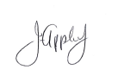
 | Mathew Walker
Respondents Details
Esperance Earth Works Pty Ltd
HLS WA PTY Ltd
Jacqueline Stewart Designs

Copy of Advertisement:
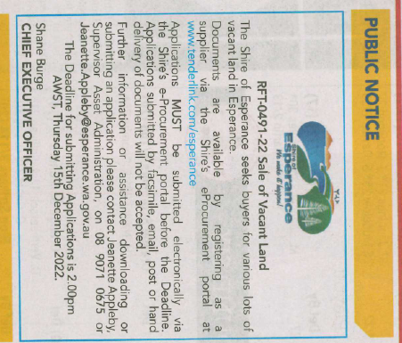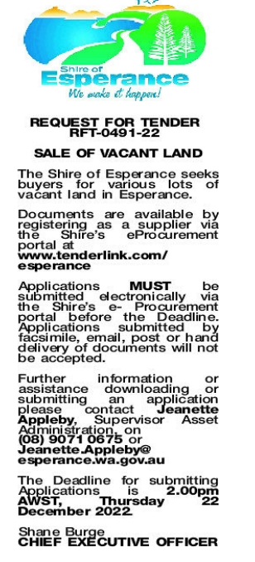
2022 Awarded by  Council |  | Date of Council Meeting  24 January 2023 |  |  |  |  |  | Council Minute No.  17.1
Name of Successful Respondent(s): |  | None Accepted
Amount of Successful Respondent(s): |  | $ Nil

