No. | 0663-25 |  | Title |  |  | Myrup Waste Transfer Station Workshop and Storage Sheds
Brief description of goods or services required | The Shire of Esperance seeks submissions from suitably qualified and experienced Contractors for the Design and Construction of Myrup Waste Transfer Station Workshop and Storage Sheds.
Particulars of the decision to invite quotes | Council Budget
Advertisement Details | Advertising Date(s):  07/11/2025  08/11/2025 |  |  | Esperance Weekender  West Australian  Tenderlink  Shire of Esperance Website  Shire of Esperance Social Media  Shire of Esperance Notice Boards
Closing Date and Time | 2.00pm AWST 11th December 2025, extended to 11th December 2025
Clarification register | Keep a record of the number and summary of each clarification issued to all respondents
Opening Date and Time | 2.00pm AWST 11th December 2025
Opened in the presence of | NAME: |  |  |  |  |  | SIGNATURE:
Opened in the presence of | Mathew Walker
Opened in the presence of | Bianca Lottering |  |  |  |  |  | 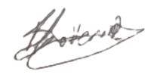
Respondents Details
- Drake-Brockman Building and Construction Pty Ltd
- McMahons Building and Construction Pty Ltd
Copy of Advertisement:
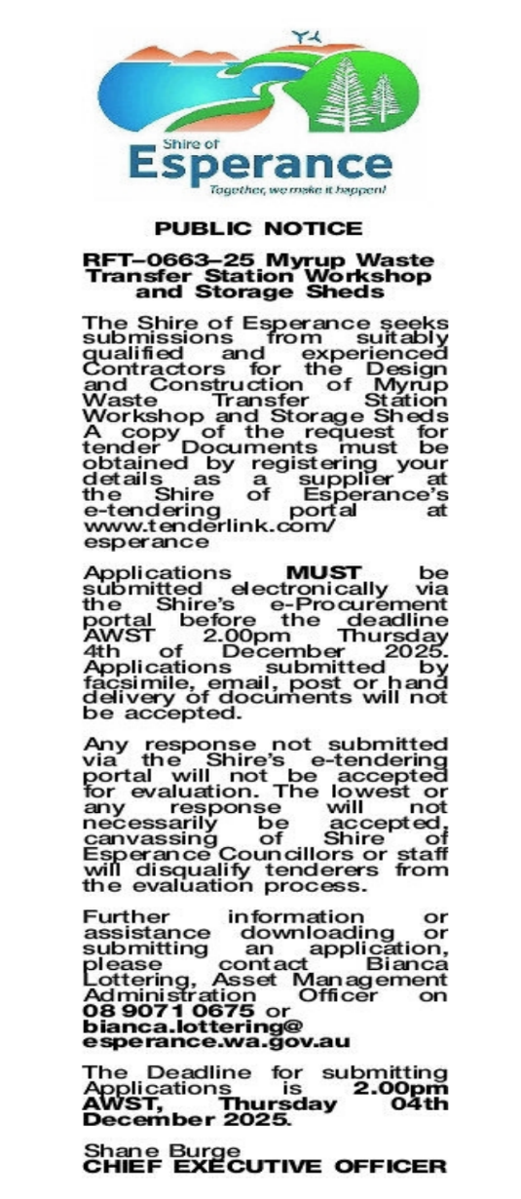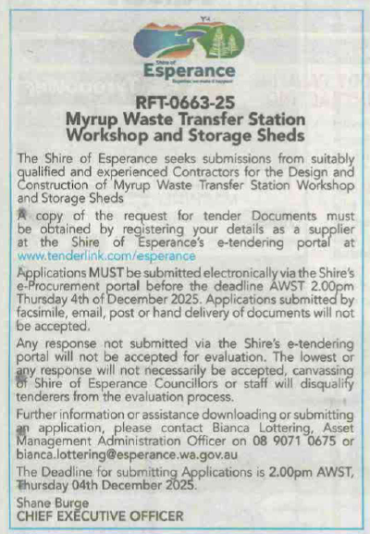
Awarded by  Council |  | Date of Council Meeting  27 January 2026 |  |  |  |  |  | Council Resolution No.  17.1
Name of Successful Respondent(s): |  | Drake-Brockman Building and Construction Pty Ltd
Amount of Successful Respondent(s): |  | $674,690 Ex GST

