No. | 0413-21 |  | Title |  | Audio Tactile Line Marking
Brief description of goods or services required | The Shire of Esperance requires the services of a suitably qualified audio tactile line marking contractor to undertake audio tactile edge line marking on the Shire of Esperance road network for road safety projects. Primarily this will be on our rural road network, but may include some urban roads.
Particulars of the decision to invite tenders | Budget Requirements
Advertisement Details | Advertising Date(s):  23 October 2021 – 6 November 2021 |  |  |  |  | Newspaper(s):  West Australian  Esperance Weekender  Kalgoorlie Miner
Closing Date and Time | 2.00pm AWST, Thursday 11 November 2021.
Clarification register | Nil Clarifications Required
Opening Date and Time | 2.00pm AWST, Thursday 11 November 2021.
Opened in the presence of | NAME: |  |  |  |  | SIGNATURE:
 | Jeanette Appleby
 | Matt Walker
Respondents Details
Supalux Line Marking Pty Ltd

Copy of Advertisement:
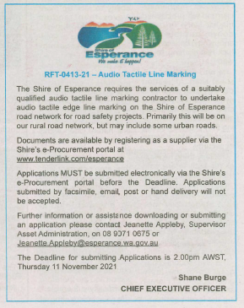

Awarded by |  | Date of Council Meeting  21 December 2021 |  |  |  |  | Council Minute No.  17.1
Name of Successful Tenderer(s): |  | Supalux Line Marking Pty Ltd
Amount of Successful Tender(s): |  | $381,80.00

