No. | 0414-21 |  | Title |  | Sale of Vacant Land
Brief description of goods or services required | The Seller is seeking to sell eight (8) residential and twenty-six (26) industrial lots of land located within the Shire of Esperance WA, which are owned in Freehold. The Land for sale contains no structures or leasing arrangements.
Particulars of the decision to invite tenders | Expressions of Interest
Advertisement Details | Advertising Date(s):  20 Nov 2021  27 Nov 2021 |  |  | Newspaper(s):  West Australian  Esperance Weekender
Closing Date and Time | 2.00pm Thursday 9 December 2021
Clarification register | Keep a record of the number and summary of each clarification issued to all tenderers
Opening Date and Time | 2.00pm Thursday 9 December 2021
Opened in the presence of | NAME: |  |  |  |  | SIGNATURE:
 | Jeanette Appleby |  |  |  |  | 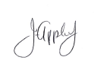
 | Mathew Walker |  |  |  |  | 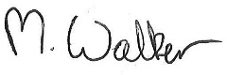
Respondents Details
Polmac Super Manager Pty Ltd ATF Polinwka Super Fund

Copy of Advertisement:
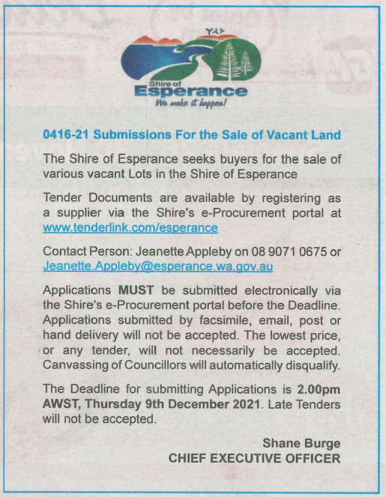

Awarded by |  | Date of Council Meeting  21 December 2021 |  |  |  |  | Council Minute No.  Item 17.3
Name of Successful Tenderer(s): |  | N/A
Amount of Successful Tender(s): |  | N/A

